Students are thoroughly enjoying the Active After School programs this term and we are consistently getting a roll call of 20+ children. This program is proving very popular and is also keeping our students active and learning new sports and leisure time activities. It is also a valuable, free service for our working parents. I urge those that have some interest in coaching or particular expertise in a given sport to consider becoming an AASC coach. Please read further in the newsletter to find out how.

Discussions are in progress also regarding Art Club for 2013. Please watch this space for more information.

Principal’s Report

**S. Matthews**

**Principal**

Upcoming Events

**Term 4**

Week 6

Thursday 15th November Art Club $2 with Mrs Botticchio 3:15pm - 4:30pm

Friday 16th November **Cricket Gala Day K-6**

**P&C meeting** 3:15pm All Welcome!

Week 7

Monday 19th November Explorer’s Club $2 3:15pm - 4:45pm

Tuesday 20th November **Kinder Orientation 9am-3pm**

Active After School’s Program (AASC) 3:15pm - 4:30pm

Wednesday 21st November Playgroup 9:15am – 11:00am

Active After School’s Program (AASC) 3:15pm - 4:30pm

Thursday 22nd November Art Club $2 with Mrs Botticchio 3:15pm - 4:30pm

Friday 23rd November **Freezing Fun Friday 50c**

Week 8 **SWIM SCHOOL COMMENCES**

Monday 26th November Explorer’s Club $2 3:15pm - 4:45pm

Tuesday 27th November

Active After School’s Program (AASC) 3:15pm - 4:30pm

Wednesday 28th November Playgroup 9:15am – 11:00am

Active After School’s Program (AASC) 3:15pm - 4:30pm

Thursday 29th November Art Club $2 with Mrs Botticchio 3:15pm - 4:30pm

Friday 30th November **Freezing Fun Friday 50c**

**Kindergarten Orientation**

Our Kindergarten orientation program has been running very smoothly for the past two weeks. Mrs Neale is delighted in the way the children have settled into classroom activities and all teachers observed how well they handled the recess break and enjoyed time in our playground. As usual our older students have been very helpful in easing them into school life.

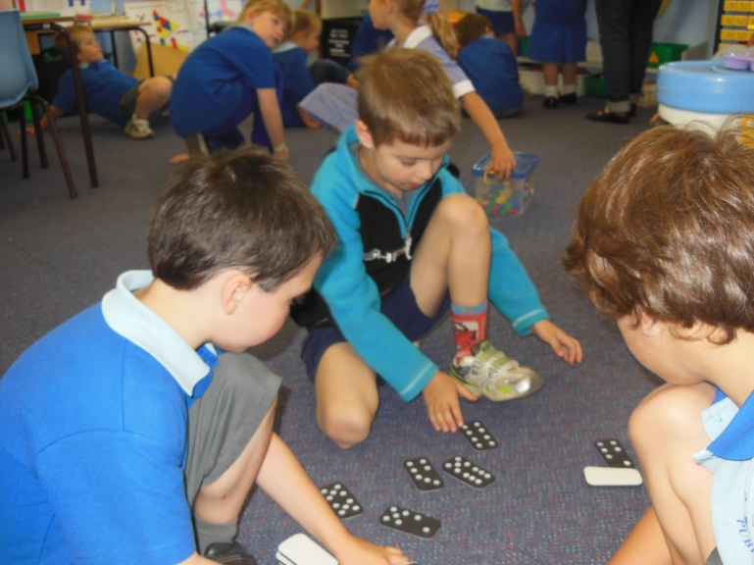

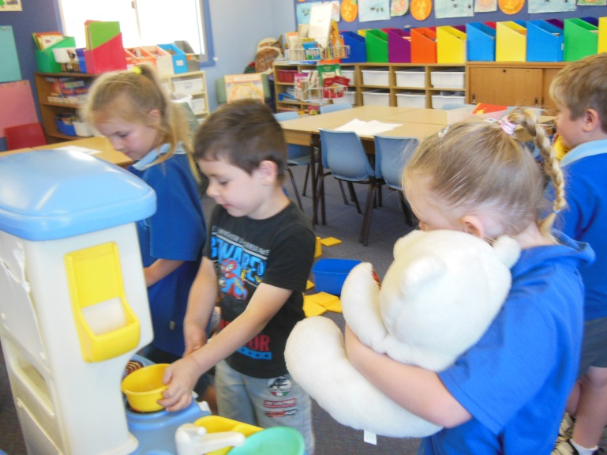





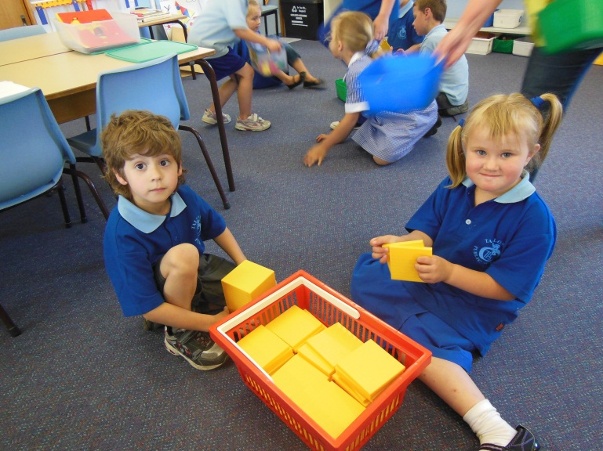

**P&C Footy Tipping Winner**

Congratulations to Chrissy Wursten and Riley Maguire who were winners in the P&C NRL footy tipping competition this year. Chrissy and Riley were awarded their prizes at last weeks’ assembly by P&C president Jeremy Porter and last year’s winner, Mr Randall.

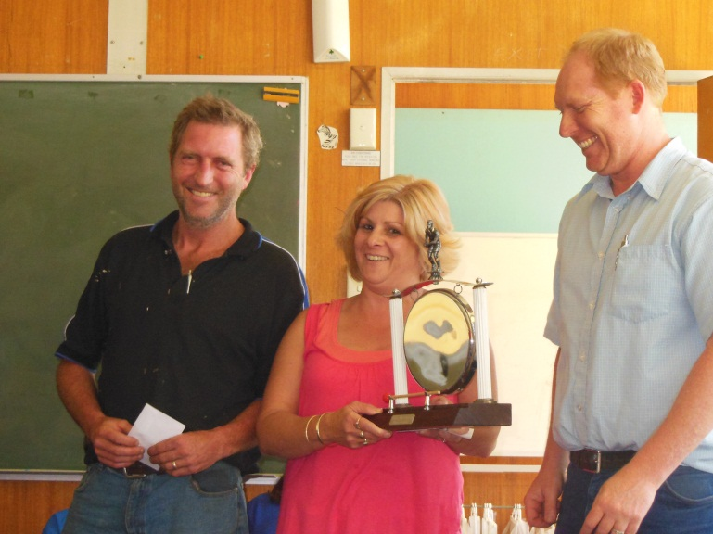

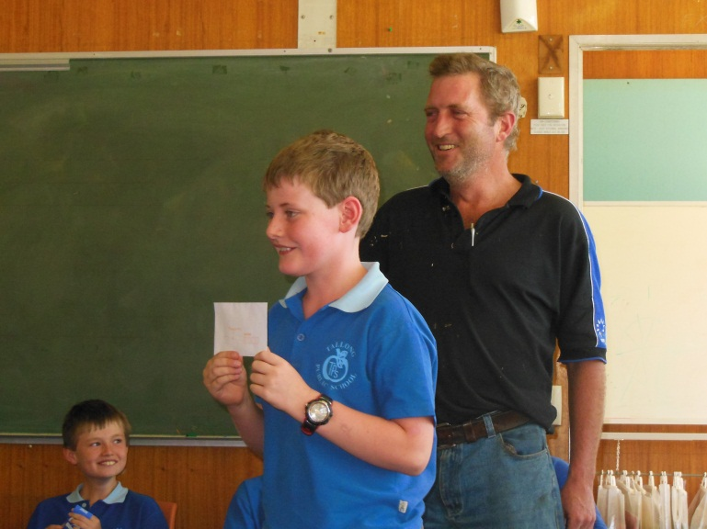

**Freezing Fun Fridays!**

Ice blocks will be available for sale by the SRC on Fridays for 50c throughoutTerm 4.

C:\Users\susan.m.matthews\AppData\Local\Microsoft\Windows\Temporary Internet Files\Content.IE5\5EAPGJTS\MC900391306[1].wmf

**Coaches Needed!!!!**

If the Active After School program is to be sustainable in our school, it is necessary that we have community members willing to become coaches. This would involve a one day training course and a short online course. All the activities are prepared for you and this makes the program very simple to run. Coaches are paid a minimum of $40 each session. The commitment would be for 7 sessions in a school term. It may be that you are involved for one term each year. It is entirely flexible.

If you think this might be something you could be involved in please return the expression of interest attached to the newsletter to the school office and we can then connect you with the program organisers.

C:\Users\susan.m.matthews\AppData\Local\Microsoft\Windows\Temporary Internet Files\Content.IE5\2OBT5ISJ\MC900332882[1].wmfPlease consider this if you have ever coached a sport, have knowledge about a particular sport, have an interest in earning some extra cash. There is always a staff member on duty to organise the students and support you during the session.

**GRC Concert**

Miss Keva Abotomey, our wonderful music teacher, is holding a concert in Goulburn for the involvement of all her students across a number of schools.

Miss A is wanting to showcase the wonderful musical talent of student’s at Tallong Public School in this concert to be held in Belmore Park, Goulburn on 2nd December, 2012. We are hoping to involve as many students as possible from our school and hope your child can be part of this. Please read the note attached to last week’s newsletter and **confirm participation by 16th November, 2012.**

C:\Users\susan.m.matthews\AppData\Local\Microsoft\Windows\Temporary Internet Files\Content.IE5\2OBT5ISJ\MC900057671[1].wmf

**Community Garage Sale**

Just a reminder to all the HUGE Community Garage Sale is still on Saturday 24th November commencing 8am.  There’s currently 10 locations on the MAP and still time to let Lyn Blazer know if you want to be part of this ‘clearing of the clutter’!